**Farmer Plus**

SRS Quality Report

28/12/2010

FAST – NUCES

Revision History

**Project Advisor**

Sir. Waqar Ahmed

**Project Team**

Qasim Ifzal – L080969

Amber Shahid – L095061

Tahir Rauf – L095068

Muhammad Zubair – L080808

|  |  |  |  |
| --- | --- | --- | --- |
| **Date** | **Version** | **Description** | **Author** |
| <25/12/2010> | <1.0> | <Initiation of the document> | Syed Qasim Ifzal |
| <28/11/2010> | <1.1> | <First Review> | Syed Qasim Ifzal  Amber Shahid |

Table of Contents

1. Quality Checker 4

1.1 Completeness 4

1.2 Correctness 4

2. Measurement 5

2.1 Completeness (Requirements) 5

2.1.1 Classes of Input data (1 for complete and 0 for incomplete/no input) 5

2.2 Completeness (Document) 6

2.3 Correctness (Requirements) 6

2.3.1 Trace to Need [Refer Traceability Matrix – APPENDIX – A] 6

APPENDIX – A 7

Reference 8

# Quality Checker

According to the SQA plan (Section 4.4.1), the quality shall be measured according to the following criterion.

|  |  |  |  |  |  |
| --- | --- | --- | --- | --- | --- |
| **SRS Checklist** | | | | | |
| **Sr#** | **Specifications** | **Comply** | | | **Overall Quality (Q) $Q=\frac{Qr+Qd+Qc}{3}$**  **= 94.6%** |
| **Y** | **N** | **NA** |
| 1 | Are all requirements complete - Qr = | 93.75 % |  |  |
| 2 | Are all requirements correct - Qd | 98.46% |  |  |
| 3 | Is the requirements document complete - Qc | 91.67 % |  |  |

## Completeness

The criteria for ***completeness***, as discussed by [1], are as follows:

**Requirements completeness**

1. Responses of the software to all realizable classes of input data in all realizable classes of situations is included

$$Q r=\frac{N\left(d\right)}{N(t)} x 100$$

Where $N\left(d\right)$ is the number of requirements for which input classes have been defined and $N\left(t\right)$ is the total number of requirements.

**Documentation Completeness (*Q d*)**

1. All pages numbered; all figures and tables numbered, named, and referenced; allterms defined; all unitsof measure provided; and all referenced material present
2. No sections of the document is marked as “To be determined”

$$Q d=\frac{N\left(l\right)}{N(t)} x 100$$

Where $N\left(l\right)$ is the number of labeled document objects (tables, figures etc) for which input classes have been defined and $N\left(t\right)$ is the total number of object types.

## 1.2 Correctness

The criterion for ***correctness***, as discussed by [1], refers to the fact that every requirement contributes towards the satisfaction of some need of the user. It is measured as follows:

* Percentage of requirements in the SRS that have been validated.

$$Q c=\frac{N\left(v\right)}{N(t)} x 100$$

Where $N\left(v\right)$ is the number of requirements that have been validated and $N\left(t\right)$ is the total number of requirements. Validation is done through

Tracing the origin of each requirement to **need**

# Measurement

## Completeness (Requirements)

### 2.1.1 Classes of Input data (1 for complete and 0 for incomplete/no input)

|  |  |  |  |  |  |  |  |  |
| --- | --- | --- | --- | --- | --- | --- | --- | --- |
| No | Req ID | Input | No | Req ID | Input | No | Req ID | Input |
| 1 | ILF1 | 1 | **23** | IPF9 | 1 | **45** | SPF2 | 1 |
| 2 | ILF2 | 1 | **24** | IPF10 | 1 | **46** | SPF3 | 1 |
| 3 | ILF3 | 1 | **25** | SLF1 | 1 | **47** | SPF4 | 1 |
| 4 | ILF4 | 1 | **26** | SLF1 | 1 | **48** | SPF5 | 1 |
| 5 | ILF5 | 1 | **27** | SLF2 | 1 | **49** | SPF6 | 1 |
| 6 | ILF6 | 1 | **28** | SLF3 | 1 | **50** | SPF7 | 1 |
| 7 | ILF7 | 1 | **29** | SLF4 | 1 | **51** | SPF8 | 1 |
| 8 | ILF8 | 0 | **30** | SLF5 | 1 | **52** | SPF9 | 1 |
| 9 | ILF9 | 1 | **31** | SLF6 | 1 | **53** | CMF1 | 1 |
| 10 | ILF10 | 1 | **32** | SLF7 | 1 | **54** | CMF2 | 1 |
| 11 | ILF11 | 1 | **33** | SLF8 | 1 | **55** | CMF3 | 0 |
| 12 | ILF12 | 1 | **34** | SLF9 | 1 | **56** | CMF4 | 1 |
| 13 | ILF13 | 1 | **35** | SLF10 | 1 | **57** | CMF5 | 0 |
| 14 | ILF14 | 1 | **36** | SLF11 | 1 | **58** | CMF6 | 1 |
| 15 | IPF1 | 1 | **37** | SLF12 | 1 | **59** | CMF7 | 1 |
| 16 | IPF2 | 1 | **38** | SLF13 | 1 | **60** | CMF8 | 1 |
| 17 | IPF3 | 1 | **39** | SLF14 | 1 | **61** | CMF9 | 1 |
| 18 | IPF4 | 1 | **40** | SLF15 | 1 | **62** | CMF10 | 1 |
| 19 | IPF5 | 1 | **41** | SLF16 | 1 | **63** | CMF11 | 0 |
| 20 | IPF6 | 1 | **42** | SLF17 | 1 | **64** | CMF12 | 0 |
| 21 | IPF7 | 1 | **43** | SLF18 | 1 | **65** | CMF13 | 1 |
| 22 | IPF8 | 1 | **44** | SPF1 | 1 |  |  |  |
| *Requirement Completeness Qr= 60/64 x 100 = 93.75%* | | | | | | | | |

## Completeness (Document)

|  |  |  |  |
| --- | --- | --- | --- |
| Sr No | Quality Attribute | Value | Comments |
| 1 | All pages are numbered | 1 |  |
| 2 | All pages are named | 1 | Header/footer |
| 3 | All pages are referenced | 1 | Table of contents |
| 4 | All figures are numbered | 1 |  |
| 5 | All figures are named | 1 |  |
| 6 | All figures are referenced | 1 | List of figures and Tables |
| 7 | All tables are numbered | 1 |  |
| 8 | All tables are named | 1 |  |
| 9 | All tables are referenced | 1 | List of figures and Tables |
| 10 | All terms are provided | 1 |  |
| 11 | All referenced material are provided | 0 |  |
| 12 | All sections are present. | 1 |  |
| *Document Completeness (Qd) = 11/12 x 100= 91.67%* | | | |

## Correctness (Requirements)

### 2.3.1 Trace to Need [Refer Traceability Matrix – APPENDIX – A]

|  |  |  |  |  |  |  |  |  |  |  |  |
| --- | --- | --- | --- | --- | --- | --- | --- | --- | --- | --- | --- |
| No | Req ID | Traced | No | Req ID | Traced | No | Req ID | Traced | No | Req ID | Traced |
| 1 | ILF1 | 1 | **18** | IPF4 | 1 | **35** | SLF10 | 1 | **52** | SPF9 | 1 |
| 2 | ILF2 | 1 | **19** | IPF5 | 1 | **36** | SLF11 | 1 | **53** | CMF1 | 1 |
| 3 | ILF3 | 1 | **20** | IPF6 | 1 | **37** | SLF12 | 1 | **54** | CMF2 | 1 |
| 4 | ILF4 | 1 | **21** | IPF7 | 1 | **38** | SLF13 | 1 | **55** | CMF3 | 1 |
| 5 | ILF5 | 1 | **22** | IPF8 | 1 | **39** | SLF14 | 1 | **56** | CMF4 | 1 |
| 6 | ILF6 | 1 | **23** | IPF9 | 1 | **40** | SLF15 | 1 | **57** | CMF5 | 1 |
| 7 | ILF7 | 1 | **24** | IPF10 | 1 | **41** | SLF16 | 1 | **58** | CMF6 | 1 |
| 8 | ILF8 | 0 | **25** | SLF1 | 1 | **42** | SLF17 | 1 | **59** | CMF7 | 1 |
| 9 | ILF9 | 1 | **26** | SLF1 | 1 | **43** | SLF18 | 1 | **60** | CMF8 | 1 |
| 10 | ILF10 | 1 | **27** | SLF2 | 1 | **44** | SPF1 | 1 | **61** | CMF9 | 1 |
| 11 | ILF11 | 1 | **28** | SLF3 | 1 | **45** | SPF2 | 1 | **62** | CMF10 | 1 |
| 12 | ILF12 | 1 | **29** | SLF4 | 1 | **46** | SPF3 | 1 | **63** | CMF11 | 1 |
| 13 | ILF13 | 1 | **30** | SLF5 | 1 | **47** | SPF4 | 1 | **64** | CMF12 | 1 |
| 14 | ILF14 | 1 | **31** | SLF6 | 1 | **48** | SPF5 | 1 | **65** | CMF13 | 1 |
| 15 | IPF1 | 1 | **32** | SLF7 | 1 | **49** | SPF6 | 1 |  |  |  |
| 16 | IPF2 | 1 | **33** | SLF8 | 1 | **50** | SPF7 | 1 |  |  |  |
| 17 | IPF3 | 1 | **34** | SLF9 | 1 | **51** | SPF8 | 1 |  |  |  |
| *Requirement Correctness Qc= 64/65 x 100 = 98.46%* | | | | | | | | |  |  |  |

# APPENDIX – A

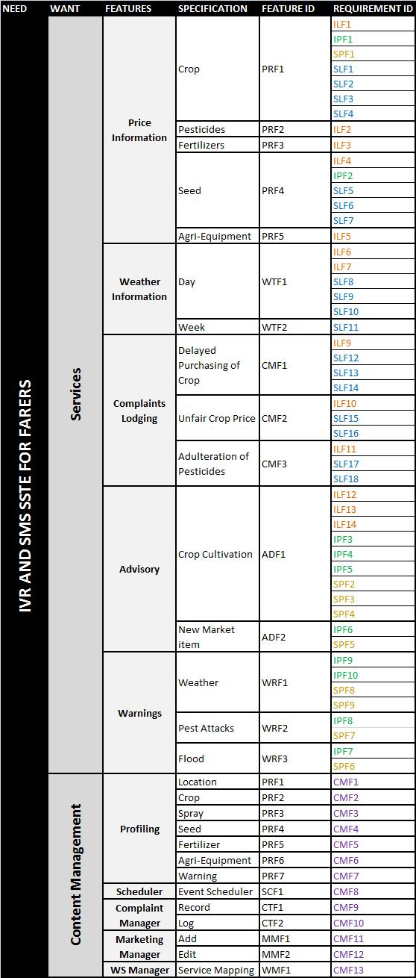

**TABLE 4: Traceability Matrix**

# Reference

[1] Identifying and Measuring Quality in a Software Requirements Specification By Alan Davis, Scott Overmyer, Kathleen Jordan, Joseph Caruso, Fatma Dandashi, Anhtum Dinh, Gary Kincaid, Glen Ledeboer, Patricia Reynolds, pradip Sitaram, Anh Ta, and Mary Theofanos